Who We Are:

Troop 1532 is a Scout-run Troop focused on building:
- Moral Character and Strength
- Leadership
- Citizenship
- Mental and Physical Fitness
- Love of the outdoors

To achieve these we emphasize the Scout Law.
A Scout is:
- Trustworthy
- Loyal
- Helpful
- Friendly
- Courteous
- Kind
- Obedient
- Cheerful
- Thrifty
- Brave
- Clean and
- Reverent
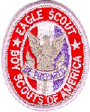
What We Do:

- Camping
- Hiking
- Backpacking
- First Aid
- Swimming
- Canoeing
- Biking
- Sailing
- Leading
- Volunteer / Charity Work
- Community Service
- Caving
- Merit Badges
- Outdoor Skills
- Many other activities!

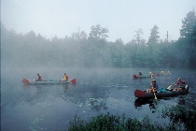

Meetings:
- Most School Year Monday evenings
- 7:30-8:45 PM
- St Ambrose School Gymnasium,
3827 Woodburn Rd, Annandale, VA, 22003
Requirements to Join:

- Completed 5th Grade, or
- At least 11 years old
- Less than 18 years old

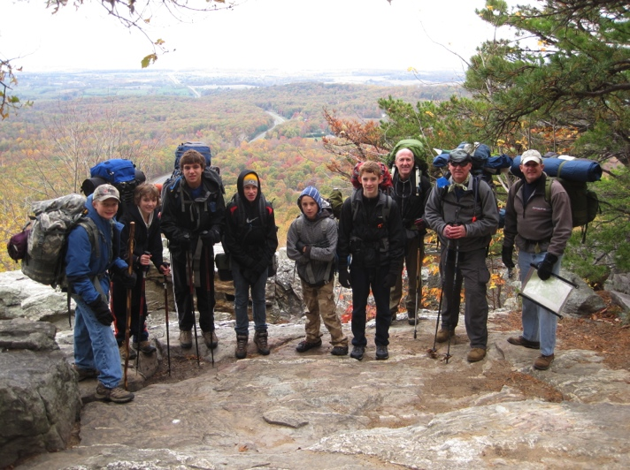

Contact info:
- Bill Huddleston
- Phone: (703) 434-9780
- E-Mail: billhuddleston1@gmail.com
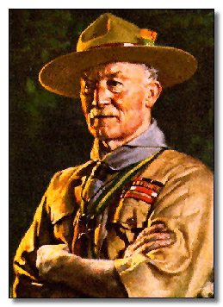
Sir Robert Baden-Powell,
founder of Scouting

